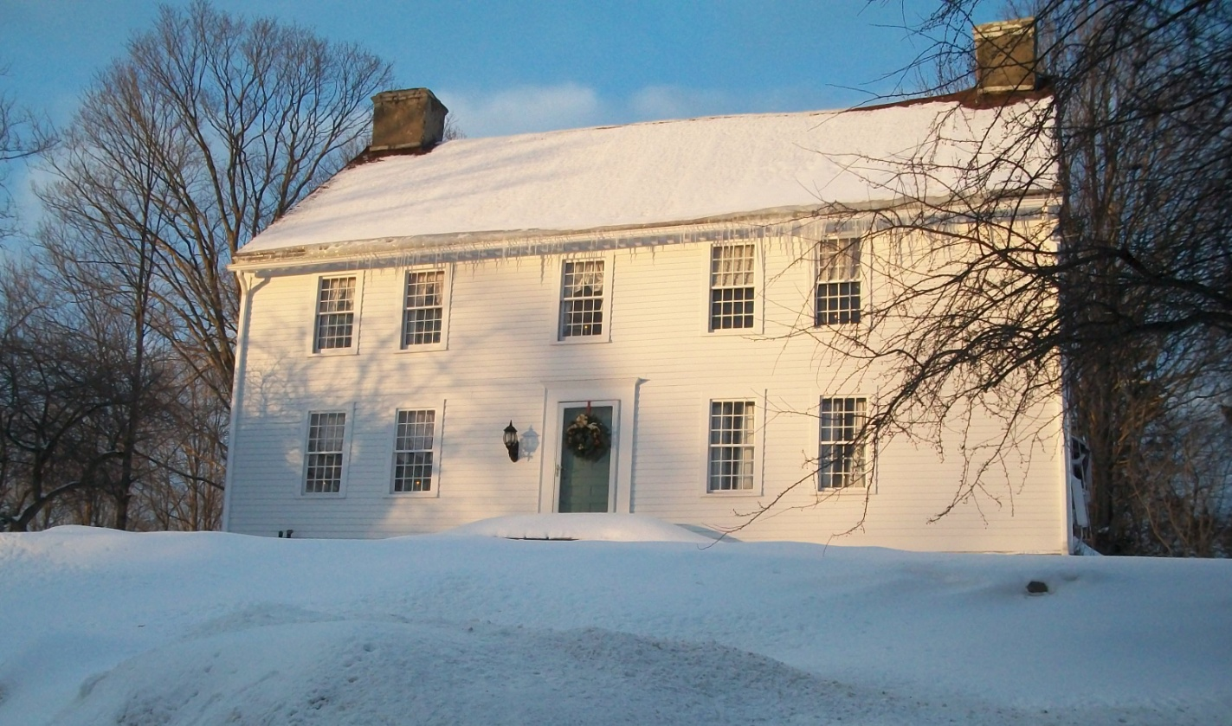

142 Church Street
Amston, CT

One of the first setttlers to the town of Hebron was Nathaniel Phelps.
His son, Alexander, was born in 1724.In 1724, when Alexander became of age, his father gave him 20 acres along with a very new house on the property. This “very new house” still stands today at 142 Church Street in Amston.
In 1764, Alexander sold house and property to David Carver. It remained in the Carver family until 1856. It was then sold to Hezekiel Bissell. His son, Asa, acquired the property in 1885.
In 1911 the property went to Benjamin and Mary Bissell. In 1914, the property was purchased by Bennie Kassman. The Kassman’s remained in the house until 1960 at which time they sold the house to Thorton Secor.
Jerry Gay purchased the house from the Secor’s in and sold it to Hayden Huston early 2000’s.
In 2002, Gerald and Susan purchased the house and surrounding 1.69 acres from Mr. Houston and currently reside there.

