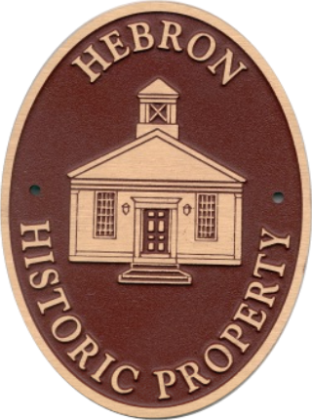
Hebron Historic
Properties Commission
15 Gilead Street
Hebron, CT 06248

Deena Watson, Chairman
Mary Ann Foote, Vice Chairman
Susan G. Morin, Secretary
Jon Minard
Rebecca Scorso
Rich Cassata
Janice Tarbell

