HEBRON HISTORIC PROPERTIES COMMISSION
PRELIMINARY STUDY REPORT FOR DESIGNATING A HEBRON
RESIDENTIAL PROPERTY AS AN HISTORIC PROPERTY

The Hebron Historic Properties Commission (HHPC) proposes that the Town of Hebron designate a homestead in Hebron as an Historic Property because of its historical significance to the community and because this structure provides excellent educational opportunities for current and future generations, as well as others interested in Hebron’s past history of early settlers.

Historical Significance: Formal, legal documents provide undisputed evidence regarding the significance of 150 East Street, the most likely site of the 1787 seizure of Reverend Samuel Peters’ slaves, Cesar and Lowis and their eight children by southern slave traders. The slaves were quickly rescued by their white Hebron neighbors and were emancipated by the Connecticut General Assembly in January 1789.

150 East Street, Hebron CT

The property proposed for designation as an historic property is located at 150 East Street, a town-owned property generally referred to as “The Peters House.” The residence sits at the entrance of what will soon be Hebron’s largest municipal park facility.

Ownership of this house has been subject to much detailed research because of the numerous transfers of property in and among the Peters family in the late 18th and early 19th century. The Peters family was extremely influential during the years leading up to the Revolutionary War, and especially the Reverend Samuel Peters, who was minister for both the Hebron and Hartford Anglican churches, and an outspoken Loyalist who ultimately fled to England in 1774 just before the onset of the American Revolution as a result of his views.

Peters also owned a number of slaves, including Cesar and Lowis Peters and their children. While in England, and in settlement of his taxes and debts, Reverend Peters ordered his property sold, which was interpreted to mean the sale of his slaves. In a well-documented event, on September 27, 1787, the Cesar Peters family was seized by David Prior of South Carolina and a gang of men Prior had hired. Hebron residents concocted a ruse to rescue the family, claiming that Cesar had not paid for his clothes and therefore had to return to first return to Hebron to face those charges of “theft.”

The history of Reverend Samuel Peters and the abduction, rescue and emancipation of his slaves, Cesar and Lowis, has been documented for over 100 years by Hebron’s unofficial historians, F. C. Bissell and Susan Bingham Pendleton, and by the current official Town Historian, the Hebron Historical Society.

The debate regarding this subject property has revolved around whether the house was actually owned by the Reverend Samuel A. Peters, and whether the abduction of Cesar Peters and his family occurred at this house. There has also been ongoing debate about the architectural significance of the house, regardless of the ownership issue.

To address these questions, the Hebron Historic Properties Commission, in partnership with the Connecticut Trust for Historic Preservation, the Connecticut Commission on Culture and Tourism, and the Town of Hebron, have applied for and received a number of grants to better understand the significance of the house and to determine if local historic designation was appropriate for the house.

Bruce Clouette, as part of a 2006 Historic Preservation Technical Assistance Grant (HPTAG), financed by the Connecticut Trust for Historic Preservation and the Town of Hebron, researched a number of sources and concluded:

“… the land on which the house stands was never owned by the Reverend Samuel Peters, even though he did own some 600’ of East Street frontage (35 acres) at the southern end of the property, which formerly was a corner of East Street and Skinner Lane. The John S. Peters lot to the north, at the corner of East Street and Burnt Hill Road, was also owned by Rev. Peters in the late 18th century and was considered part of the same farm as the 36 acres at the southern end of the subject lot. Rev. Peters acquired this land in 1774 from his brother Bemslee Peters, the father of the governor-to-be (John S. Peters) (Hebron Land Records Vol. 6, Page 284). The proximity of the Bemslee-Rev. Samuel-Governor John S. Peters farm, bordering the subject property on both the north and the south, may account for the tradition that Rev. Peters owned the house…Instead, the property on which the subject house stands was the long-time residence of George Peters (1797-1881), who inherited it from his father Jonathan Peters (1766-1812), who in turn inherited it from his father, Jonathan S. Peters (1737-1778), the brother of Rev. Peters. It is apparent from the record that it was part of a large property on both sides of East Street originally owned by John Peters (1695-1754), the first of the family to settle in Hebron…”

With regard to the question on whether the abduction of Cesar Peters occurred at the house, Clouette concluded:

“Notwithstanding the fact that the Reverend Samuel Peters did not own the house, it is highly likely that the abduction of Caesar Peters and his family occurred on the property at 150 East Street.” [Emphasis Clouette] Clouette basis this finding on a letter dated August 7, 1783 (four years before the 1787 seizure) from David Sutton to Ralph Pomeroy and Rev. Peters that “Negro Peters lives in widow Abigail Peters’s shop, cares for the glebe, and has five children…” Clouette further writes: “Abigail Peters was the widow of Jonathan Peters, the owner of this property, who died in 1778. No record was found of Abigail Peters owning or having a right to any other property with a dwelling other than this home farm.”

It is important to note that Dr. Wayne Normile Metz, in his dissertation submitted in 1974 in partial fulfillment for his Ph.D. degree in History from Oklahoma State University, on pages 92-98 of that dissertation document, reached substantially the same conclusions at Clouette regarding the seizure of the Cesar Peters family at 150 East Street.

With regard to the question regarding the architectural significance of the property, based on an architectural study, as part of that same 2006 HPTAG grant, John Obed Curtis documented the house’s most notable architectural features as:
(1) Elegant entrance pavilion flanked by monumental Doric pilasters that support a projecting triangular pediment
(2) Six-panel front entrance door flanked by smaller Doric pilasters beneath an architrave, frieze and cornice, surmounted by a triangular pediment
(3) Within the frieze, a full half-circle glazed fan light; glazing of the fan light is set within wooden muntins
(4) A scheme for a comparable entry and pediment is illustrated in William Paine’s Builder’s Pocket Treasure, an English architectural pattern book published in London in 1794
(5) A “classically correct” three-part Palladian Window, which lights the second floor hall
(6) North end of house retains original clapboards secured with hand-made nails
(7) Foundation above grade on front and two sides feature red Connecticut sandstone with bush hammer tool marks visible on most surfaces
(8) Dominant kitchen fireplace designed on the Rumford principal with shallow firebox, flaring side jambs, and large stone hearth; original wooden trim around the fireplace survives (there are a total of six fireplaces in the house, all original)
(9) Wide-board original floors still exist in the majority of the rooms
(10) A “best parlor” room on the southwest corner of the house that features “bold and elegant” cornice embellished with “nicely formed” modillion blocks, a built-in cupboard, original chair rail, and a Federal chimney piece with widely flared mantel shelf and incised triglyph motifs in the capitals of the stylized pilasters
(11) An original staircase with cut-out scroll work
(12) Northwest bedchamber with original woodwork throughout and an extremely rare built-in case of six graduated drawers, the construction of which indicate late 18th century carpentry
(13) A large ballroom encompassing the entire south side of the second floor, featuring a “tray” ceiling embellished with large incised triglyph motifs; this type of ceiling enjoyed brief popularity from approximately 1790 to 1810; the ballroom also features a single row of original benches against the entire south wall with hinged lift tops and were probably used for storage and guest seating
(14) Attic features oak or chestnut beams and rafters, with wooden pegs and workers’ cut marks clearly visible
(15) Cellar features sill level framing all hand hewn by broad axe or adze with the exception of two large timbers on each side of the chimney base; chimney foundation in the cellar features construction indicative of the late 18th century
(16) An ell that Curtis believes was originally a free-standing dwelling probably constructed sometime during the third quarter of the 18th century. He notes: “It is representative of a type of housing stock that once sheltered the majority of the populace but today is a very great rarity.” The ell also contains an extremely unique red sandstone fireplace, the materials and construction of which indicate dating the ell to the third quarter of the 18th century.

Curtis concludes his architectural study with, among other comments, “The so-called Peters House is virtually a text book example of the skillful blending of the traditional and the high-style by an imaginative and innovative house wright to create a façade elevation that is a Connecticut classic... Not only is the house significant at the local level, it is important within the context of the state as well. It is unquestionably of National Register caliber.”

Following the results of these detailed studies focused on the three primary debate questions (Reverend Peters’ ownership of the house; actual or probable location of the abduction of Cesar and Lowis Peters and their family; and architectural significance of the house), the Hebron Historic Properties Commission (HHPC) then turned to detailed studies on land records and title searches. As a result, the following was learned.

According to research conducted by HHPC and Robert B. Hurd (in conjunction with a 2005 Historic Preservation Technical Assistance Grant) the ownership chronology starting with the Town of Hebron’s is as follows:

Current Owner: Vol. 375 Page 700: To Town of Hebron From M&M Poultry Farms LLC 26 August 2004
The tract is described as: “A certain tract or parcel of land located easterly of the northeasterly line of East Street in the Town of Hebron, County of Tolland, State of Connecticut depicted as Lot 3 on a plan entitled “Hidden Acres Two, LLC Access Easement Plan, East Street, Hebron, CT.

Beginning at the southerly corner of Lot 3of said plan, said point being located N 52° 53’ 45” E 397.36 feet from the intersection of the northeasterly line of East Street and the centerline of the former Skinner Lane, said line being bounded southeasterly by land now or formerly of Christopher G. and Amy Briscoe, thence along the dividing line for Lot 2 and Lot 3 for the next six courses,

N 35° 39’ 49” W 439.91 feet to a point,
N 24° 31’ 58” W 523.94 feet to a point,
N 41° 35’ 06” E 281.66 feet to a point,
N 48° 58’ 53” E 505.76 feet to a point,
S 25° 15’ 24” E 396.82 feet to a point,
S 18° 02’ 16” E 685.40 feet to a point on the centerline of the former Skinner Lane, then along said centerline for the following two courses, bounded by land now or formerly of Ronald J. Emanuelson, Robert W. & Susan Marie Strickland,

S 51° 47’ 57” W 210.33 feet to a point,
S 53° 05’ 40” W 100.01 feet to a point,

Thence continuing along the centerline of said Skinner Lane and bounded partially by land now or formerly of Ronald J. Emanuelson, Robert W. & Susan Marie Strickland and partially by land now or formerly of Christopher G. & Amy Briscoe S 52° 41’ 05” W 290.20 feet to the point of the beginning.

Important note for this proposed historic property designation: The proposed designation does not include the entire parcel at 150 East Street, currently owned by the Town of Hebron, and consisting of approximately 120 acres. It includes only that portion of the property on which is situated the so-called “Peters House”, which is bounded roughly by the following:

To the west of the subject property by East Street;
To the north of the subject property by approximately 100 feet from the northern-most wall of the residence;
To the east of the subject property by approximately 100 feet from the eastern-most wall of the residence;
To the south of the subject property by the existing access road to the total parcel.

Previous owner (1): Vol. 290 Page 17 To M&M Poultry Farms LLC From Hidden Acres Two LLC, 10 June 2002.

Previous owner (2): Vol. 184 Page 335 To Hidden Acres Two LLC From Hidden Acres LLC, 4 August 1997.

Previous owner (3): Vol. 181 Page 196 To Hidden Acres LLC From Hidden Acres (reflecting name change), 18 February 1997

Previous owner (4): Vol. 128 Page 213 To Hidden Acres From Intensity Holdings, 21 August 1987

Previous owner (5): Vol. 128 Page 210 To Intensity Holdings From Green Acres Farms, Inc., 21 August 1987

Previous owner (6): Vol. 61 Page 159 To Green Acres Farms, Inc. From Melvin W. Strickland and Ronald J. Emanuelson, 29 July 1967

Previous owner (7): Vol. 60 Page 567 To Melvin W. Strickland From Monica C. Post, 21 March 1967

Previous owner (8): Vol. 60 page 511 To Monica C. Post From Estate of F. Elton Post (a Probate Order), 27 February 1967

Previous owner (9): Vol. 31 Page 298 To F. Elton Post From Frank R. Post, 17 September 1934

Previous owner (10): Vol. 24 Page 283 To Frank R. Post From Estate of George Peters, a Probate Order, 20 March 1882

As part of a 2006 Historic Preservation Enhancement Grant, jointly funded by the Town of Hebron and the Connecticut Commission on Culture and Tourism, Joan M. Rowley continued tracing ownership of the property starting with George Peters and previous owners. Her research is summarized below.

George Peters Land Records

Instrument:
Date Instrument Grantor/ Grantee
4/7/1821 QC V.14 P.153 Jonathan Peters to George Peters
Property: The Burnt Hill Lot distributed to Elizabeth and Abigail by father

4/7/1821 QC V. 14 P. 154 Jonathan Peters to George Peters
Property distributed to Jonathan and Samuel by father

9/12/1826 QC V. 15 P. 160 Caroline Peters 2nd to George Peters 2nd
Property Distributed to Caroline by father

9/10/1828 QC V. 15 P. 199 Joseph P. Peters to George Peters
Property distributed to Joseph P. by father

4/21/1829 QC V. 15 P. 82 George Peters & Samuel A. Peters
to John S. Peters
Property: 64 acres 10 rods formerly owned by Abigail Peters
10/16/1833 QC V. 17 P. 28 Otis T. Peters to George Peters
Property distributed to Otis by father

3/23/1837 WD V. 17 P. 220 Josiah Gilbert to George Peters
Property: 4 acres

8/16/1876 WD V. 22 P. 563 George Gilbert to George S. Norton
Property: 4 acres referred to as “Gilbert lot”

4/28/1838 QC V. 17 P. 106 Emily Peters to George Peters
Property distributed to Emily by father

4/8/1844 WD V. 18 P. 247 Estate of Samuel Peters to
George Peters
Property: 42 acres on west side of road with buildings

4/26/1844 WD V. 19 P. 19 Heirs of Samuel Peters
to George Peters
Property: 5 ¼ acres on west side of road
5/13/1844 WD V. 19 P. 20 George Peters to Francis West
Property: One Half Interest in 47 acres with dwelling & other buildings

5/17/1845 WD V. 19 P. 62 Heirs of Joseph P. Peters to
George Peters
Property: 20 acres on west side of road

4/21/1849 QC V. 20 P. 161 John A.(?) Peters to
George Peters
Property: 12 acres

3/26/1846 Mtg.19/83 Wm. Lee to George Peters
Description: Mortgage Deed $77.54

3/15/1857 W.D. V. 22 P.16 Nelson A. Lee to George Peters
Description 90 Rods House & Barn

4/3/1858 QC V.21 P.92 George Peters to Ashael Lee
Description: 90 Rods House and Barn

4/3/1858 Mtg. V.23 P. 28 Ashael Lee to George Peters
Description: 90 Rods House & Barn $150.00

10/9/1859 QC V.21 P. 109 George Peters to Ashael Lee
Description: 90 Rods House & Barn; Mtg. Release

2/28/1860 WD V. 22 P. 80 Mary M. Peters to George Peters
Description: (1) 65 acres with dwelling; (2) 36 Acres Bound South on Skinner

2/28/1860 WD V. 22 P. 81 George Peters to Mary M. Peters
Description: (1) 20 acres; See V. 19 P. 62; (2) 47 ½ acres in common with Francis West; See V. 19 P. 20

1/9/1867 WD V. 22 P. 272 George Peters to Silas Loomer
Description: 30 Acres on Burnt Hill

2/15/1879 WD V. 22 P. 625 George Peters to Charles D. Way
Description: First tract from Mary Peters; See Vol. 22 P. 80; Subject to Mortgage (V. 23 P. 1039)

3/16/1861 TR. V. 21 P. 673 St. Peters to George Peters
Description: Cemetery Lots 108 & 109

George Peters Mortgages

2/28/1860 V. 23 P. 59 Mary M. Peters
Description: On 2 tracts V. 22 P. 80

4/15/1871 V. 23 P. 355 H.A. Bissell
Description: $452.00; 75 acres Being the same land I bought of John Welles called The Governor Peters Farm; Rel. 5/8/1877 V. 21 P. 647

5/30/1871 V. 23 P. 1035 Town of Hebron
Description: 60 Acres; $300.00

2/7/1872 V. 23 P. 1039 Town of Hebron
Description: 64 acres; $721.91

6/11/1877 V. 23 P. 372 H.A. Bissell
Description: Two Parcels, 65 acres and 35 acres called the John S. Peters Place

12/11/1878 V. 23 P. 398 Joel and Ann Wilcox
Description: 130 acres With a large dwelling House and other buildings

3/20/1882 V. 24 P. 283 Estate of George Peters
Description: 130 Acres with Dwelling and other Buildings; $ 331.00 to Frank R. Post

The property is identifiable on the 1744 Pinney map of Hebron:
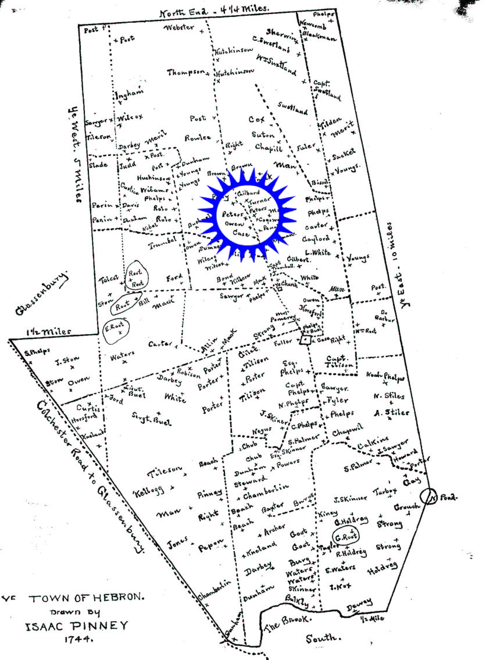

The property is also identifiable in the 1869 map of Hebron:

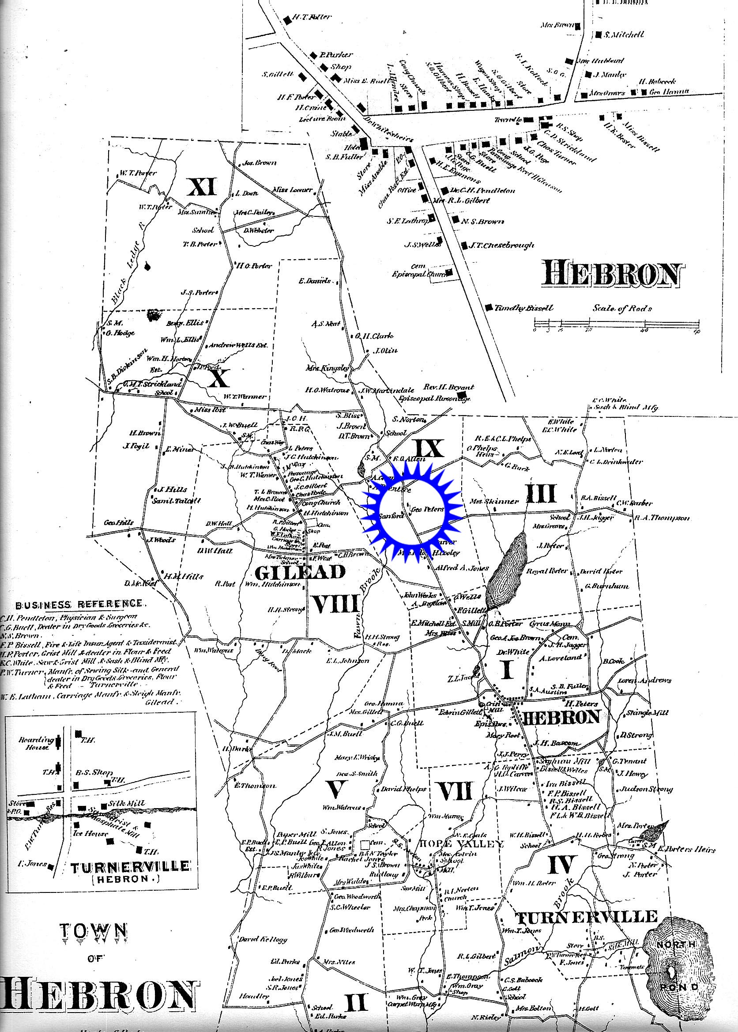
The current Assessor’s map of the location of the Peters House at 150 East Street, identified in the current parcel of approximately 120 acres of town-owned open space, is as follows:

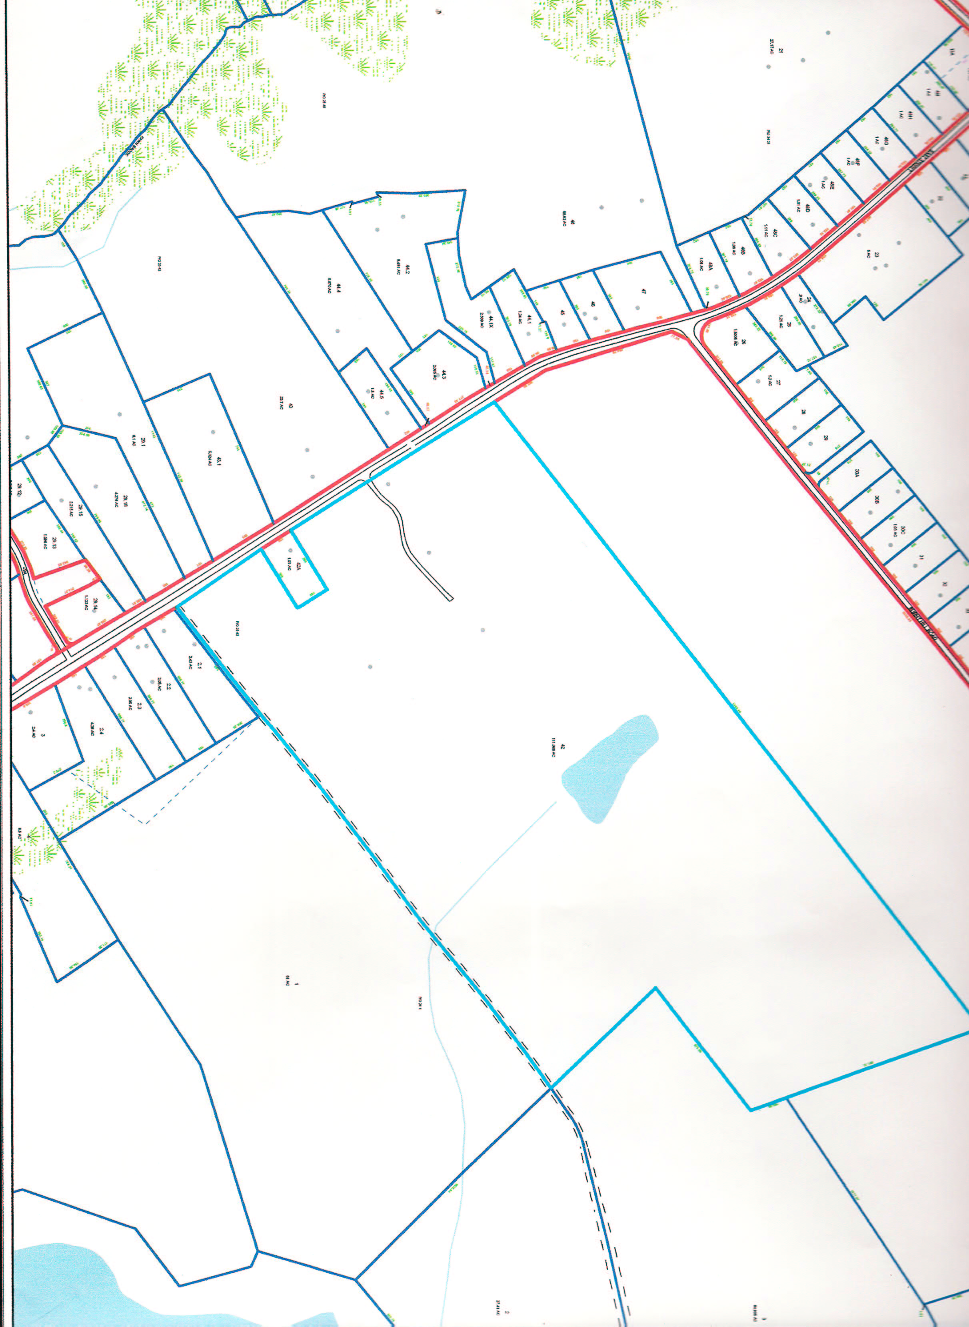

Recently, a photograph of the home taken in the 1960’s has been uncovered in the Hebron Town Clerk’s office. An unknown photographer took this picture of the Peters House, which at that time was owned by Selectman Elton Post and his wife Monica, who served as Hebron’s Tax Collector. Many residents still remember going to the “Peters House” to pay their taxes.

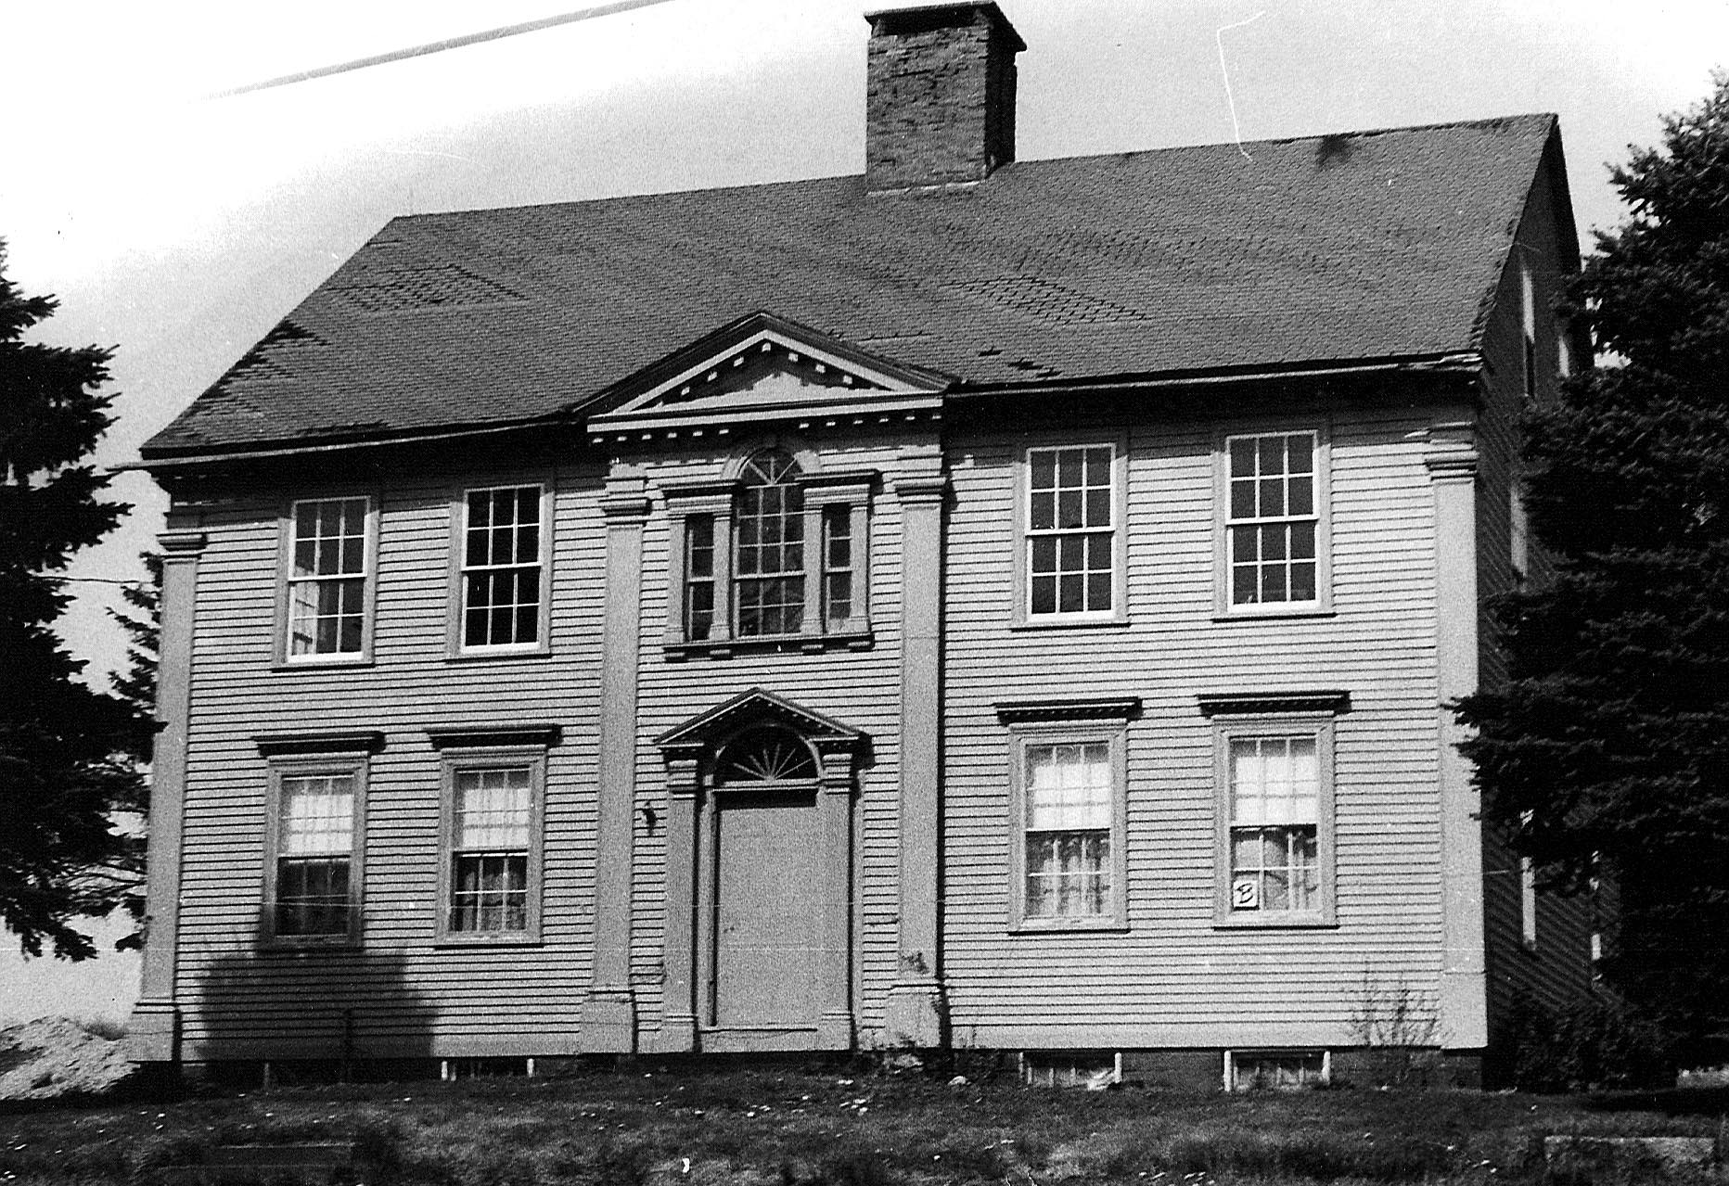

In addition, a 1944 picture taken by Reverend George Milne and other members of the Gilead Congregational Church, in their documentation on Hebron’s historic homes, included this picture of the house, noting that it had been owned by George Peters, Frank R. Post and F. Elton Post:

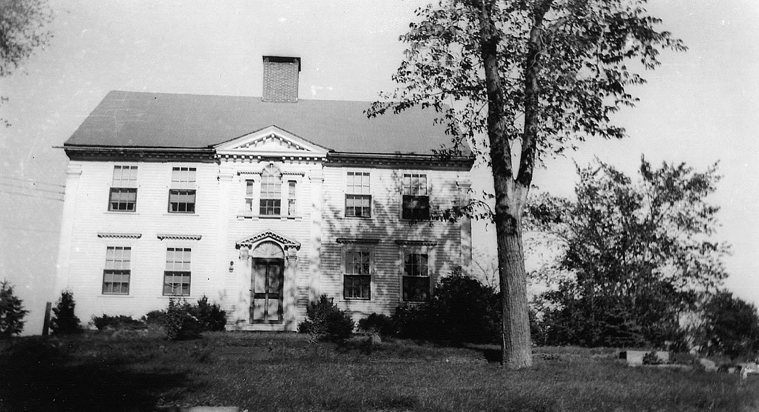
In August 2004, residents of Hebron overwhelming approved the purchase of 112 acres of land located at 150 East Street, which included the historic Peters House, as an open space land acquisition.

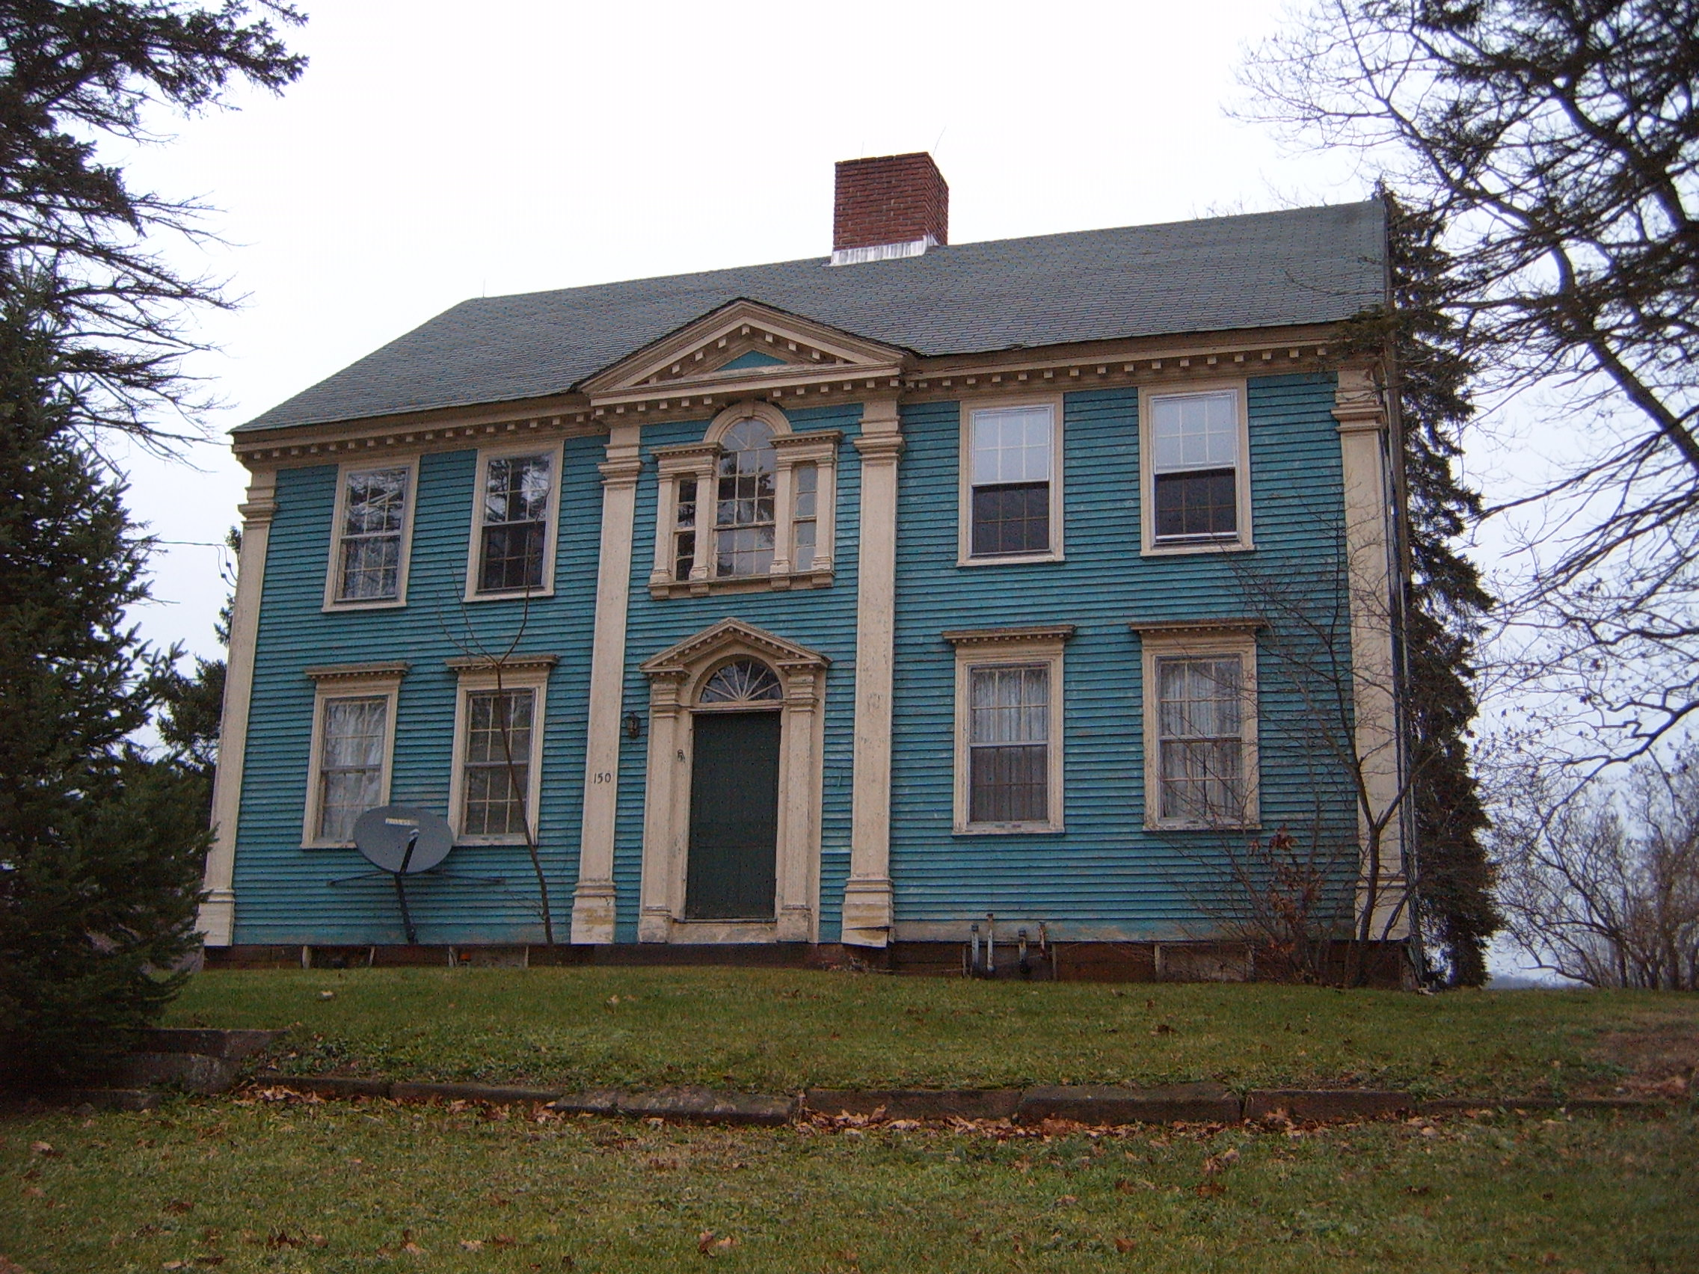

Since the town formally acquired the property – and the historic “Peters House” – there have been a number of significant activities involving the house and the abduction, rescue and emancipation of the slaves Cesar and Lowis Peters and their eight children:

- numerous articles regarding the history of the house, and the future of the house, have appeared in the following publications: New York Times, Hartford Courant, Journal Inquirer, Rivereast, Willimantic Chronicle, Regional Standard, Hebronian, and Hebron/Marlborough Life
- the saga of Cesar and Lowis’ rescue by their white Hebron neighbors has been included in a web portal created by Yale University’s Gilder Lehrman Center, celebrating five significant events in Connecticut abolitionism. The educational program is entitled “Citizens All: African Americans in the Nutmeg State, 1700-1850” and is targeted to middle and high school students. That program can be accessed at: http://cmi2.yale.edu/citizens_all/
- a Culture and Tourism Partnership Grant was awarded in 2007 to the Hebron Historical Society and Patio Productions to partially fund a film color short on the Cesar and Lowis story, tentatively entitled “Testimonies from a Quiet New England Town”
- a Culture and Tourism Special Initiative Grant was awarded in 2008 to the Hebron Historical Society to continue funding for an expanded version of the “Testimonies of a Quiet New England Town” film
- In late August 2007, the Amistad Commission notified the Hebron Historical Society of its desire to include the Peters House, as a symbol of the abduction and rescue of Cesar and Lowis Peters, in the Connecticut Freedom Trail, a highly prestigious honor shared by only 42 other Connecticut towns and 100 other locations on the Trail; the Historical Society has requested Hebron Historic Properties Commission to partner in this designation. The letter from the Amistad Committee is as follows:

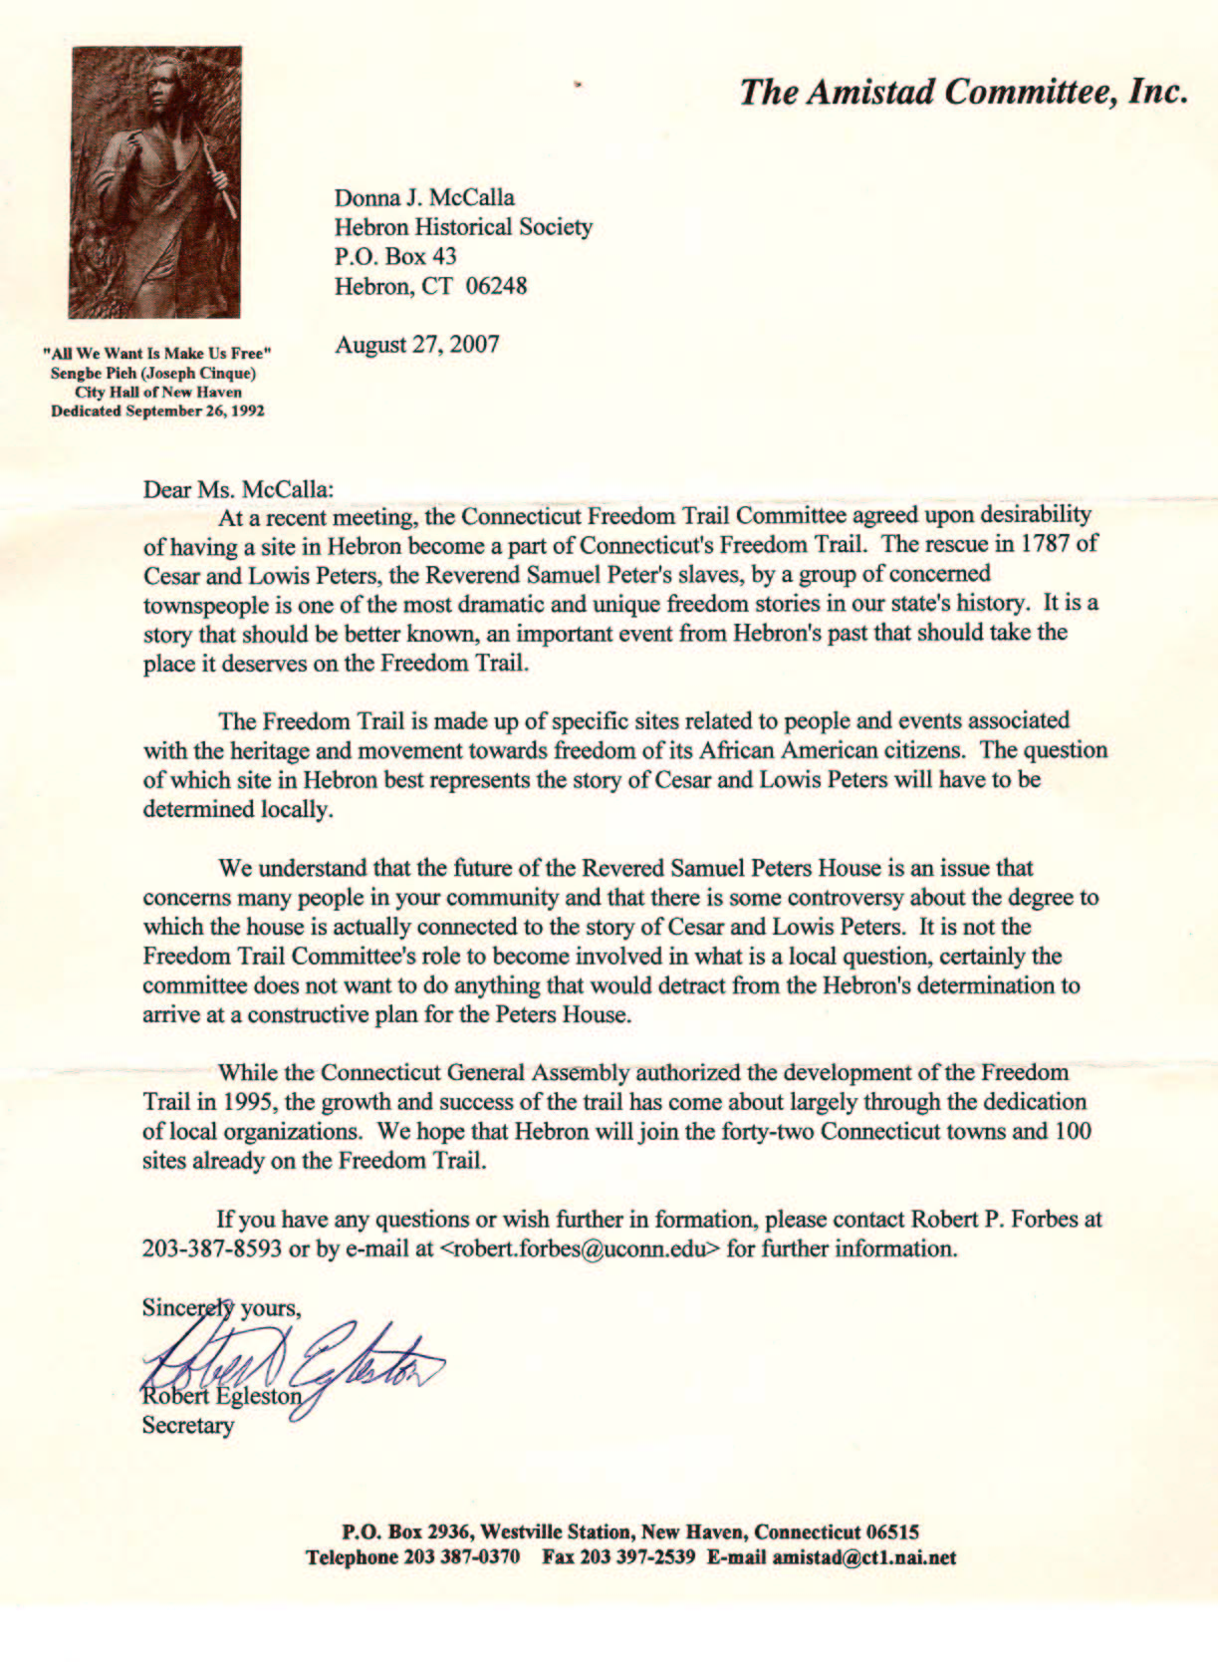

While future ownership of the house remains uncertain, the historical, cultural and architectural significance of the so-called “Peters House” makes it a worthy candidate for local historic designation.

THEREFORE, the Hebron Historic Properties Commission recommends that the Hebron Board of Selectmen designate this an historic property by amending Ordinance 94-1, “An Ordinance Establishing a Local Historic Properties Commission and Designating an Historic Property,” with the following description from Hebron Land Records and as shown on the map on page 26 of this report:

Section 7 – Designation of Historic Properties shall be amended to include:

- That portion of the property owned by the Town of Hebron, 150 East Street, Hebron, CT, on which the “Peters House” is situated and as described below, is hereby designated an historic property.

To the west of the subject property by East Street;
To the north of the subject property by approximately 100 feet from the northern-most wall of the residence;
To the east of the subject property by approximately 100 feet from the eastern-most wall of the residence;
To the south of the subject property by the existing access road to the total parcel.

Respectfully submitted,

Deena Watson
Chairman
Hebron Historic Properties Commission

